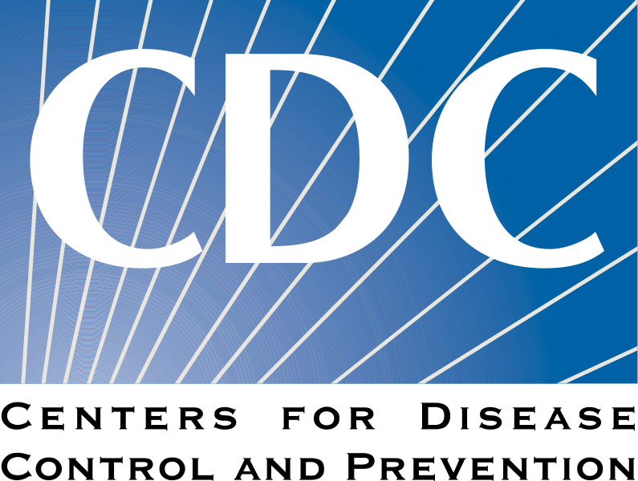
Georgia Elementary Science Olympiad
Disease Detective Event
https://www.cdc.gov/mobile/applications/sto/web-app.html

Level 1 Missions
1 - Fill in the chart as you complete each mission listed below.
2 - Be sure to record details about each case along with other helpful notes.
3 - Use the ICONS to see data and notes or click the LEARN button to learn more.
4 - The more questions you answer correctly, the higher your score will be!

Mission | Symptoms | Clues & Observations | Cause of Outbreak & Source | Treatments &/or Precautions
The Village of Gold

______
Points Earned
The Queens Killer

______
Points Earned
Conference Blues

______
Points Earned
Birthday Party Gone Bad

______
Points Earned

Part B: Discussion Questions - Answer these questions based on the information from your chart.

1) Which symptoms did your four cases have in common? List the top 3.

2) How many of the 4 outbreaks were caused by each of the following pathogens/toxins?

Bacteria | Virus | Parasite | Other

3) How many of the 4 outbreaks were treated with the following treatments?

Antibiotics | Antiviral | Vaccine | Other | None

4) What four things can we learn from an epi-curve? Hint: Click the LEARN button if you do not remember.

5) Which badges did you earn?

6) Use the search tools on the CDC website to learn more about the diseases you explored in this activity.

 | Name of Disease | Most Recent Case(s)  Where & When | How many people were affected? Explain how.
1
2
3
4

